**Business plan**

**Starting Japanese restaurant in New York**

By Carol

Apr 2021

1. **Business Problem**

Global economic is badly harmed by COVID-19, yet the wide adoption of vaccination is a sign to revoke our business especially tourism and entertainment. So to big city like New York, let’s plan

* What restaurant has more potential to grow?
* Would Japanese restaurant have a competitive edge? When more people are looking for healthy and balanced diets
* Which location is more potential?

1. **Methodology**

There are two sources to support the discussion

* Basic information (neighborhoods and boroughs, latitudes, and longitudes) about New York City is collected from <https://cocl.us/new_york_dataset>
* FourSquare API provides data about existing Japanese restaurant location and quality

Then we comment the existing and potential growth of different areas. By sorting and visualization, recommend the best location of starting a new Japanese restaurant.

1. **Key Findings**

* In term of neighborhoods, Queens has the most (80) whereas Manhattan has the least, only half of Queens (40)

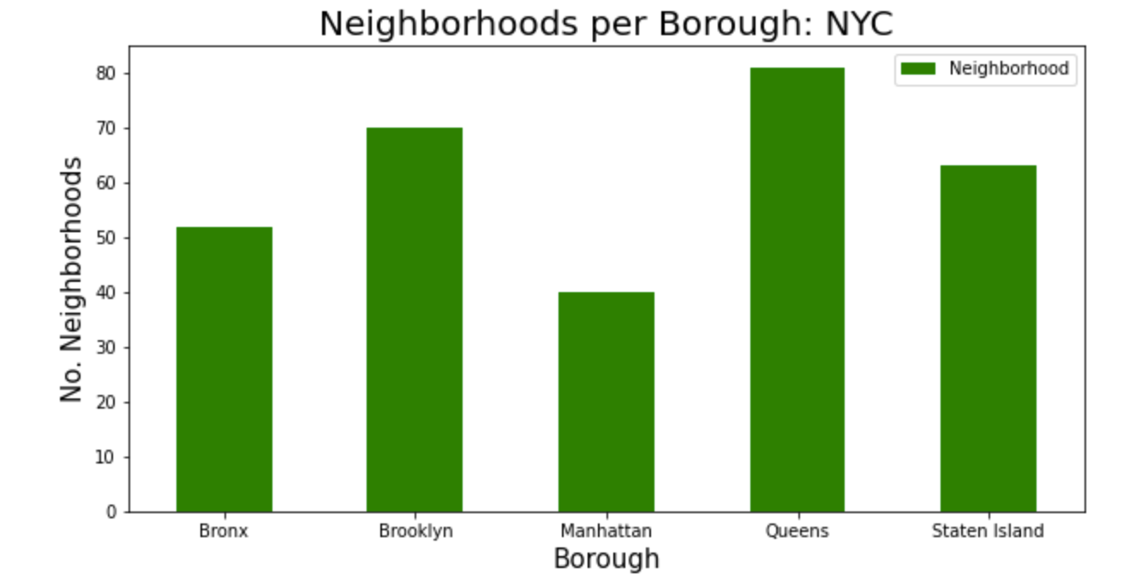

* 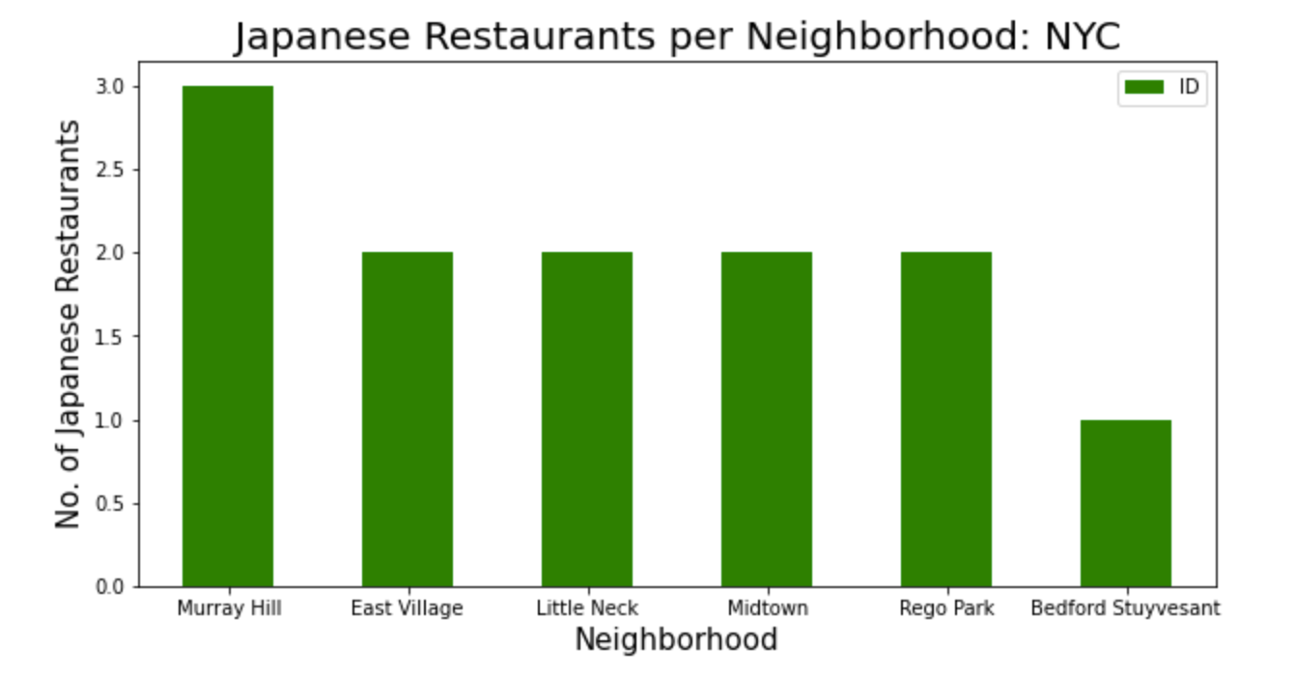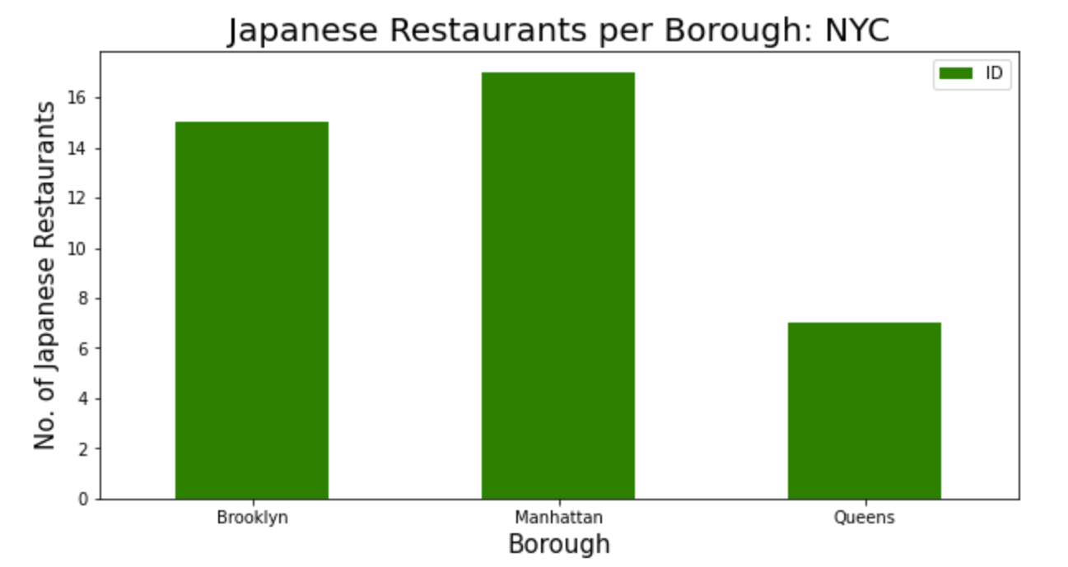39 Japanese restaurants are running currently, most are located in Manhattan (By borough); Murray Hill (By neighborhoods)
* The average score of existing Japanese restaurant is
  + 57 likes
  + 8.2 rating
  + 19 tips
* The best performers are always in Brooklyn
  + 899 likes for Samurai Mama @ Brooklyn (North Side)
  + 247 tips for Samurai Mama @ Brooklyn (North Side)
  + 9.3 rating for Kura @ Manhattan (East Village)

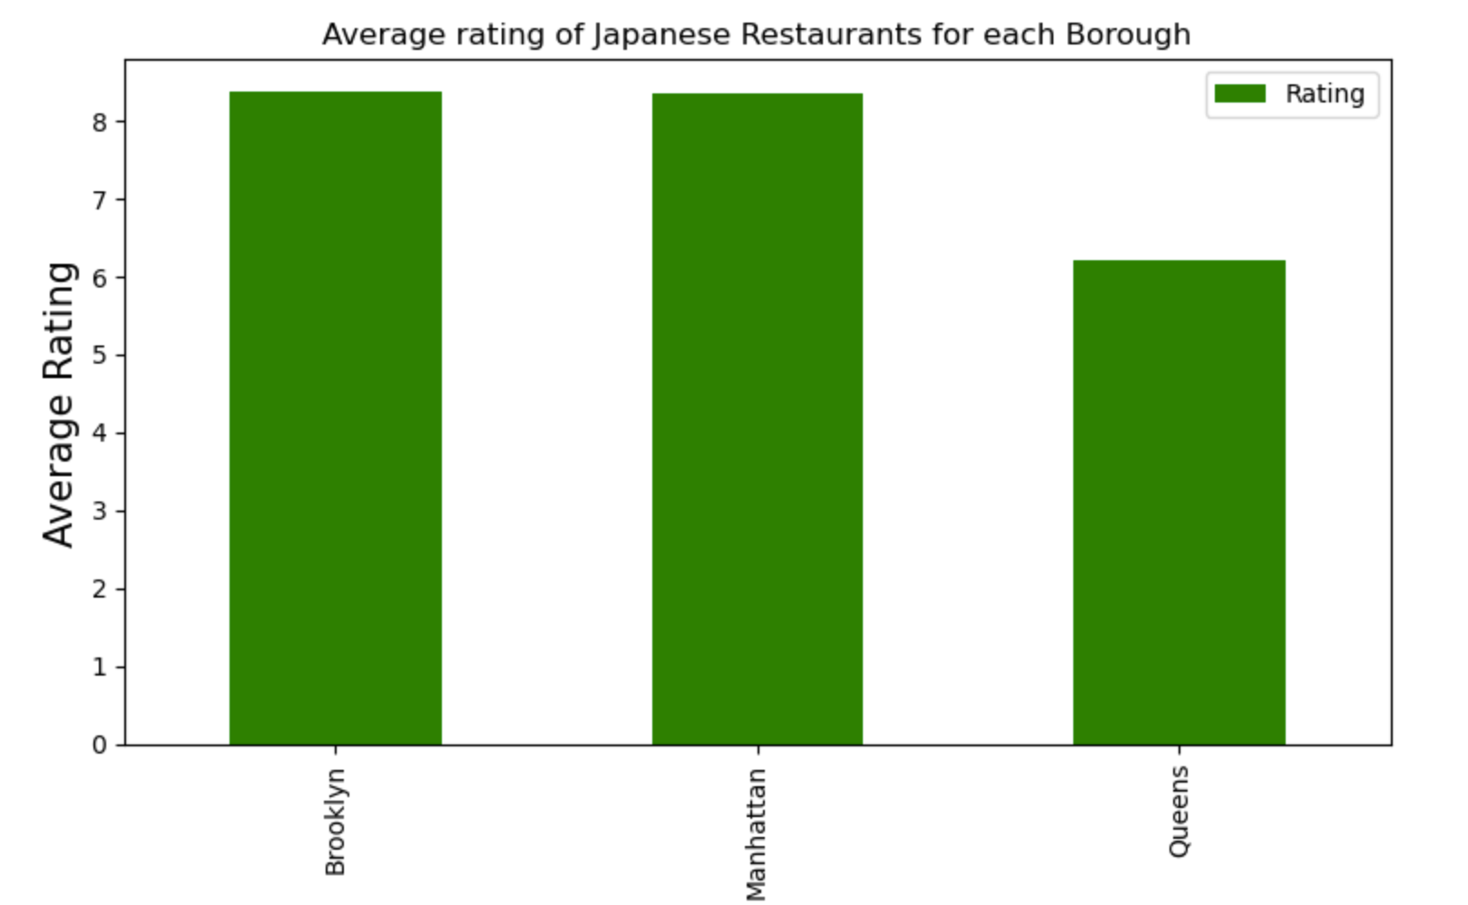

* We only look at those having rating >=9.0 as we plan to serve premium class
  + Brooklyn (Cobble Hill)
  + Manhattan (East Village)

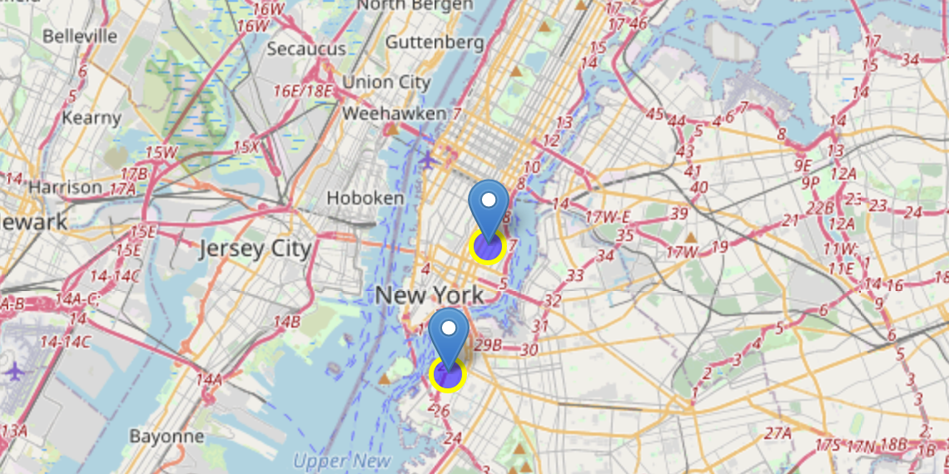

1. **Conclusion**

Brooklyn is comparatively higher potential to start Japanese restaurant having said that

* Getting multiple neighborhoods with average ratings exceeding 8.0
* Having less amount of Japanese restaurants than Manhattan, making competition easier
* Renting is cheaper than in Manhattan